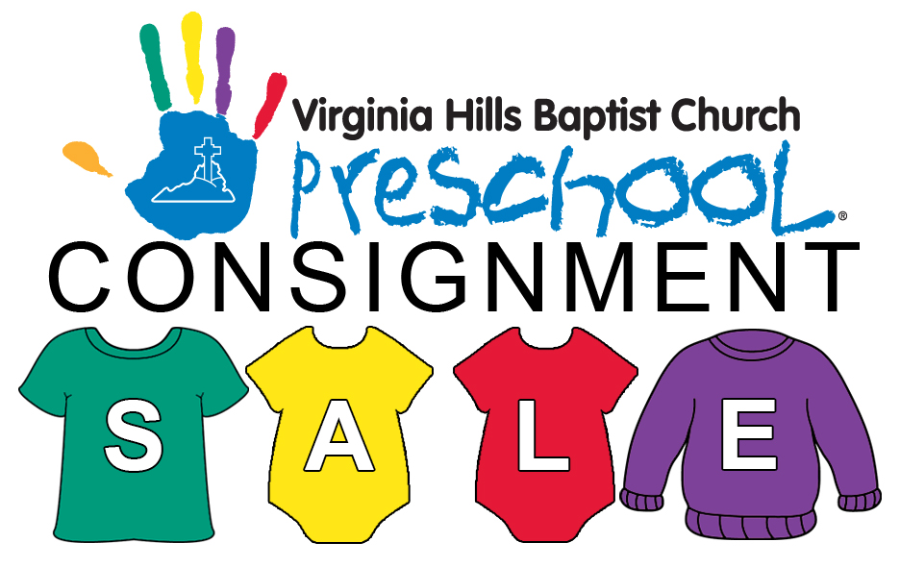
Friday, April 13, 2018
5 – 8pm

Saturday, April 14, 2018 (50% off sale)
9 – 11am

Dollar Dash 11:30am – 12:30pm (all items marked as donate will be $1.00 each)

6507 Telegraph Road
Alexandria, VA 22310

www.Facebook.com/VHBCPreschoolConsignmentSale/

***Friday, April 13 1-4pm (Preview sale only)***

Contact: consignmentsale@VHBCpreschool.org

Thank you for your interest in participating in Virginia Hills Baptist Church Preschool’s consignment sale! This is a very exciting way for everyone to buy/sell items that are no longer being used and raise money for the school at the same time.

We have compiled this information packet to provide you with all of the information that you will need to participate in our first sale, but if you have any further questions, don’t hesitate to email us at consignmentsale@VHBCpreschool.org. Please read this information thoroughly. VHBC Preschool reserves the right to reject any consignor or volunteer who has failed to comply with these instructions and the Consignor/Volunteer Acceptance Form.

Important Dates
- Consignment Sale Dates: Friday, April 13 & Saturday, April 14, 2018
Timeline for Sale:
- General Sale - Friday, April 13 from 5 - 8pm
- Last Call Shopping hours ( some items marked 50% off) - Saturday, April 14 from 9 – 11am
- Dollar Dash ( all items marked with a red or black dot for donation will be $1.00 each) – Saturday, April 14 from 11:30am – 12:30pm
Schedule of Events
      - Registration Begins—Monday, January 1st, 2018 (If transferring items from another sale, please refer to the “Pricing and Tagging’ section of this packet for more information.)
      - Registration Ends—Tuesday, April 10th, 2018 by midnight
      - Enter your items in MCM by—Wednesday, April 11th , 2018 by midnight
      - Drop off items — Thursday, April 12th, 2018 between 9am-3pm and 5-8pm (NO EXCEPTIONS!)
      - Preview Sale— Friday, April 13th , 2018 1-4pm
          - Volunteers who commit to 4 or more hours may shop from 1-4pm
          - Volunteers who commit to 2 hours may shop from 2-4pm
          - Consignors who do NOT volunteer may shop from 3-4pm
          - Sales floor will close promptly at 4pm
      - Pick Up items—Saturday, April 14th, 2018 between 2:30-3:30pm ($25 fee for consignors that do not pick up items on time)
**Due to limited space, please do not bring children to any of these events**

Guidelines for Consigning
- There is a $10 participation fee
- The number of consignors will be limited to 100. Once we have reached 100 consignors, the registration will close, even if it is prior to April 9th, 2018.
- Each consignor must have a minimum of $50 worth of merchandise to sell
- Each consignor will be responsible for pricing and tagging each item with the use of My Consignment Manager (MCM)
- Each consignor who chooses to drop off items and not volunteer to help with set up, sale day, or clean up will receive 60% of the ticketed price on all items sold
- Each consignor who chooses to volunteer a minimum of 2 hrs (does not have to be consecutive) will receive 70% of the ticketed price on all items sold and will be invited to shop during the preview sale on Friday evening
- Each consignor may choose to include items in the last call half price sale and will make this designation during the pricing/tagging process
- Each consignor may choose to have any unsold items returned to them and will make this designation during the pricing/tagging process. Consignors are responsible for picking up items that are marked for return between 6-6:30pm on the day of the sale. Consignors that do not pick up items marked for return between these times will be charged a $25 fee which will be deducted from your profits. All unclaimed items and items not marked for return will be donated to VHBC Preschool or a charity of VHBC Preschool’s choice if they are not sold. BOOKS ARE NOT ELIGIBLE TO BE MARKED FOR RETURN.

**Please like our Facebook page and share with your friends: www.Facebook.com/VHBCPreschoolConsignmentSale/

Acceptable Merchandise to Sell
- Baby/Kids clothing (up to size 12)
  - Items must be in good condition
  - ALL SEASONS accepted including Halloween costumes, uniforms, and boy/girl scout items ( winter gear is not recommended at this sale)
  - Clothing must be clean and free of stains/tears
  - Clothing must be tagged according to the guidelines in this packet
- Baby/Kids shoes in good condition
  - No scuffs, holes, or extreme wear
- Infant and Toddler furniture and equipment, i.e., high chairs, strollers, jumpers, etc.
- Toys, riding toys, wagons
  - Toys must be in working order and include batteries
  - No toys with missing parts will be accepted
  - Toys should be cleaned and sanitized
  - Electronic, talking, or Educational stuffed animals in good condition will be accepted. Batteries must be included
- Children’s books, games, DVDs, and CD’s
  - Books should be checked for missing pages and/or markings
  - Games with missing parts will not be accepted
- Maternity clothes
  - ALL SEASONS accepted

Unacceptable Merchandise
- Any item that does not meet current Regulations, Mandatory Standards, or have been Banned—please check your items at www.cpsc.gov/en/Regulations-Mandatory-Standards-Bans/
- Any items that have been recalled—please check your items at www.cpsc.gov/en/Recalls/Recalls-by-Product/
- Plush/Stuffed animals
- Items in poor condition, broken, ripped, stained, or missing parts
- Breast pumps or breast pump parts due to safety concerns
- Car seats of any kind due to safety concerns*
- Cribs or bassinets due to safety concerns*
*We suggest and encourage you check the US Consumer Product Safety Council’s website (www.cpsc.gov) for up to date information regarding any product you consign in order to maintain safety for all.

**All items will be prescreened for quality by the
consignment sale organizers and will be removed from
the sale if they do not meet these standards**

Pricing and Tagging Items
- You must log into MCM and create your profile.
- All items must be tagged using our online tagging system. NO EXCEPTIONS!
- Enter your items and the prices that you have chosen. Keep in mind that this is a consignment sale and not a yard sale. In order to make this profitable for you and the school, please price items to reflect at least 25% of the retail price, but no more than 60%.
- The minimum price that can be entered is $0.50. You may want to consider bundling small items such as socks, etc.
- All items must be priced in increments of $0.50.
- Consignor must choose to discount item 50% during the Last Call shopping hour by choosing the appropriate option in the Discount field.
- Consignors must designate items to be returned if not sold. There will be a red dot on the tag for those items that will not be returned.

- Use only one tag per item.
- Dresses, coats, costumes, and maternity items must be on hangers with the item facing to the left, i.e., the hook of the hanger should look like a question mark with the hook open to the right side of the garment. (Hangers will not be returned.) See pictures below.

- Items marked Yes in the Sale field will be included in the 50% off sale hour.
- Items marked Yes in the Donate field (Red Dot) will be donated to VHBC Preschool or a charity of VHBC Preschool’s choice if not sold. ALL BOOKS MUST BE MARKED TO DONATE AND WILL NOT BE RETURNED.
- Once your items are priced, the tags must be printed using an ink jet printer (no dot matrix) with normal (not best quality) printout. This will ensure that the barcodes can be scanned.
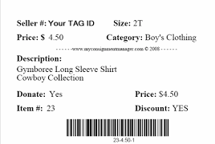
- All tags must be printed on 60-67 lb white card stock paper. Colored card stock will only be accepted if the item is being transferred from another sale. NO BLUE CARD STOCK—the scanner cannot read it.
- Please attach tags on clothing items using safety pins. (Absolutely NO straight pins, staples, tape, string, or adhesive tags)
    - Make sure that the safety pin passes throughout the tag in two places to ensure that it is securely attached.
    - DO NOT punch a hole anywhere on the tag.
    - Place the tag on the left side or shoulder of the item so it can be easily seen.

    - DO NOT place tags on the inside of the clothing item.
    - If using a tagging gun, please go through the underarm seam on the left arm to minimize damage to the fabric.

    - When selling clothing items with multiple pieces make sure that the items are pinned together with a safety pin and there is only one tag for the set.

- Securely attach tags to all non-clothing item using clear tape. Please use painters tape on any items that could be damaged by regular tape.
- Shoes should be fastened together with zip ties or twine to avoid being separated.
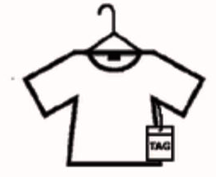
- If an item contains multiple pieces/parts, please place small items in a plastic bag. Make sure that the bag is taped close and the price tag is taped to the outside. Make only one tag for the set.
- DO NOT TAPE OVER THE BARCODE.
- TAPE ALL BAGS CLOSED.
- Items without tags will not be sold. Such items will be placed on display during the 6-6:30pm pick up to be claimed. Any items not claimed will be donated to VHBC Preschool or a charity of VHBC Preschool’s choice.
- Item tags MUST include the following information:
  - Consignor Number (this will be automatically entered by MCM)
  - Brand name and short description
  - Gender and Size (if applicable)
  - Discount status
  - Donation/Return status

Transferring from another consignment sale
- Consignors transferring tags from must be manually entered into our system. Please email consignmentsale@VHBCpreschool.org to register
- In the unlikely/unfortunate case that your previous number is one that is already assigned, then we cannot accept your old tags as is. You will have to print out new tags with your new number.
- Consignors using transferred tags are permitted to use pastel colored card stock, with the exception of blue card stock. NO ONE IS PERMITTED TO USE BLUE CARD STOCK.
- If the items being sold are being transferred from another sale, the consignor must verify the following information:
      - the seller number on the printed tag matches the registered seller number in the current sale
      - the Discount/Donate options do not conflict with those on the tag
      - the item description is not too long for the current tag

Volunteers
This sale will not succeed without the help of volunteers, so we are asking everyone to please consider volunteering at least 2 hours of your time during the set up, sale day, and/or clean up. To accommodate everyone’s unique schedules, your volunteer hours do not have to be consecutive, but they will need to be scheduled. We want this to be a fun and profitable event and hope that everyone will be able to help out! Please contact consignmentsale@VHBCpreschool.org to volunteer.

The following are descriptions of the Volunteer Spots that will need to be filled:

BEFORE SALE
- Carry In Volunteer (during Drop Off times)—assist consignors with bringing in their items (may require heavy lifting)
- Set Up Sorter (during Drop Off times)—organizes items being consigned by size, type, etc. to make set up easier on the day of the sale (may require heavy lifting)
- Sales Floor Prep (prior to Preview Sale)—prepares sales floor by setting up tables, clothing racks, etc. and places signage on tables, walls, racks, and doors

DURING SALE
- Greeter—greet customers, hand out shopping bags, answer questions during sale
hours, and explain layout of sale
- Sales Floor—monitors, organizes, and maintains a neat and orderly sales floor; answers questions; helps locate items of interest; carries toys, equipment, etc. to holding area
- Bagger—assist cashier by tracking items and placing merchandise in bags

AFTER SALE
- Breakdown Volunteer—helps to break down tables and return furniture to original locations
- Return Sorter—helps to sort items to be returned to consignor from items that are being donated.

  - Volunteers must be over 16 years of age
  - Volunteers must sign the Consignor/Volunteer Acceptance Form
  - Volunteers will be invited to shop the Preview Sale on Friday, April 13th
  - Volunteers will not be able to shop during their scheduled volunteer hours
  - VHBC Preschool will be monitoring whether volunteers have completed the required hours. All volunteers agree that they are not employees of VHBC Preschool or VHBC and will not be paid for the time spent at the sale or in preparation for the sale. VHBC Preschool and VHBC will not be responsible for any wages or overtime incurred by volunteers
  - Volunteers agree that they will not bring children during times that they are volunteering
  - Volunteers agree to not use their phone while on the sales floor during the Preview Sale or the Consignment Sale.
  - VHBC Preschool and VHBC is not responsible for items brought in by volunteers. Please leave purses, bags, coats, or any other valuables in your car or at home!
  - Volunteers need to arrive 15 minutes prior to their scheduled shift.

Sale Rules
- All Consignors and Volunteers MUST sign the Consignment/Volunteer Acceptance Form and follow the instructions. VHBC Preschool reserves the right to reject any consignor or volunteer that does not sign the Consignor/Volunteer Acceptance Form and follow the instructions.
- Consignment sale organizers reserve the right to reject any item considered unacceptable due to condition or incorrect tagging
- Consignor assumes all responsibility of theft or loss
- Items with altered prices will not be sold.
- Toys must be in working order and include batteries
- Cash and credit cards will be accepted
- Due to space limitations, NO CHILDREN OR STROLLERS will be allowed in the building
- All sales are final.
- VHBC Preschool is not responsible for any defective or broken items sold at this sale. VHBC Preschool will not provide any returns or refunds.

Getting Paid
- Before dropping off consigned items, each consignor must
  - complete and sign an acceptance form
  - submit a pre-addressed and stamped envelope if you choose to be paid by check or request to be paid by PayPal
- Checks will be mailed within 3 weeks of the end of the sale
- There will be a $25 fee for any replacement checks requested and the process may take up to 90 days

Important Disclaimers:

Security

We will make every effort to keep your items safe and secure at the sale with adequate volunteers, however, we are not responsible for lost or stolen items.

Under no circumstances may a consignor remove any unsold items from the sale floor during the sale hours. Any consignor violating this rule will forfeit their profits to VHBC Preschool and will be barred from participating in future sales.
  - Sale merchandise is not allowed in restrooms.

Liability
  - All sales are final. VHBC Preschool is not responsible for any defective or broken items sold at this sale. VHBC Preschool will not provide any returns or refunds.
  - VHBC Preschool and VHBC will not be held liable for the collection, reporting, and payment of Virginia sales tax. Sales tax is only applicable if the consignor participates in four or more sales a year. VHBC Preschool assumes that all participants will not be participating in four or more sales a year.
  - VHBC Preschool and VHBC will not be held liable for any consignor, volunteer, or buyer losses at the consignment sale; including, but not limited to, items that are lost or stolen during the sale. Consignor, volunteers, and buyers agree to indemnify and hold harmless VHBC Preschool and VHBC against any damages or claims that arise in connection with the presence at the consignment sale and their activities of any kind.
  - All consignors and volunteers agree that they are not employees of VHBC Preschool or VHBC and will not be paid for the time spent at the sale or in preparation for the sale. VHBC Preschool and VHBC will not be responsible for any wages or overtime incurred by volunteers

